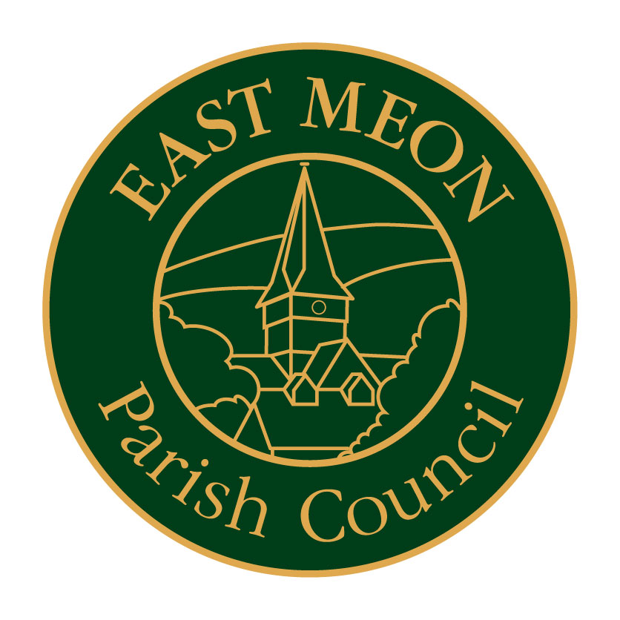

Notice
of
Planning Committee
Meeting

Reference planning Application SDNP/13/04878/FUL
Re: The Forge, East Meon

Monday 11 November 2013
at
1700 Hours
In the CHURCH HALL

